Date: 28/08/2020

**Practical no 3**

**AIM:** Write program to implement the following Transposition Cipher Techniques

a)Rail Fence Cipher b)Simple Columnar Technique

**Code:**

**a)Rail Fence Cipher**

|  |
| --- |
| import java.util.Scanner;  import java.util.logging.Level;  import java.util.logging.Logger;  public class Rails {  String Encrypytion(String plainText,int depth) throws Exception{  int r=depth, len = plainText.length();  int c= len/depth;  char mat[][] = new char[r][c];  int k=0;    String cipherText="";    for(int i=0 ; i < c ; i++) {  for (int j=0; j<r; j++) {  if(k!=len) {  mat[j][i] = plainText.charAt(k++);  }  }  }  for(int i=0 ;i<r ;i++) {  for (int j=0; j<c; j++){  cipherText += mat[i][j];    }  }  return cipherText ;  }  String Decryption(String cipherText,int depth)throws Exception{  int r=depth,len=cipherText.length();  int c=len/depth;  char mat[][]=new char[r][c];  int k=0;  String plainText="";  for(int i=0;i<r;i++) {  for(int j=0;j<c;j++){  mat[i][j] =cipherText.charAt(k++);  }  }  for (int i=0; i<c ;i++){  for(int j=0;j<r;j++){  plainText += mat[j][i];    }  }  return plainText ;  }  public static void main(String[] args) {  try {  System.***out***.println("INS Practical Performed by krunal 713");  System.***out***.println("----*--Encrypting string using RailFence cipher--*----");  Rails rf = new Rails();  Scanner scn = new Scanner(System.***in***);  int depth;  String plainText,cipherText,decryptedText;  System.***out***.println("Enter Plain Text");  plainText=scn.nextLine();  System.***out***.println("Enter depth for Encryption:");  depth=scn.nextInt();  while(plainText.length()%depth!=0){  plainText+='X';  }  cipherText=rf.Encrypytion(plainText, depth);  System.***out***.println("Encrypted text is:\n" + cipherText);  decryptedText=rf.Decryption(cipherText, depth);  decryptedText=decryptedText.replace("X","");  System.***out***.println("Decrypted text is :\n"+decryptedText);  }catch (Exception ex){  Logger.*getLogger*(Rails.class.getName()).log(Level.***SEVERE***,null,ex);  }  }  } |

**Output:**

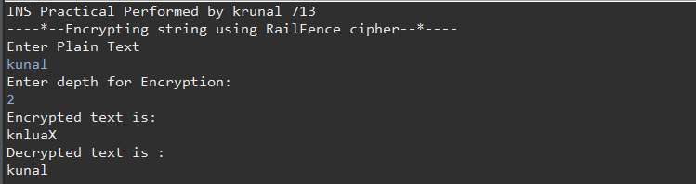

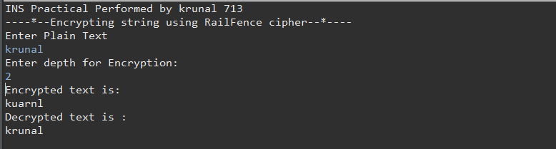

**b) Simple Columnar Technique**

|  |
| --- |
| package prac3b;  import java.io.BufferedReader;  import java.io.*;  import java.io.InputStreamReader;  import java.util.logging.Level;  import java.util.logging.Logger;  public class Sct {  public static void main(String[] args) {    try {  System.***out***.println("INS Practical performed by krunal dhavle ");  System.***out***.println("---simple column transposition ");  BufferedReader br = new BufferedReader(new InputStreamReader(System.***in***));  System.***out***.println("Enter your plain text");  String accept = br.readLine();  System.***out***.println("Enter of rows ");  int r = Integer.*parseInt*(br.readLine());  System.***out***.println("Enter the cols");  int c = Integer.*parseInt*(br.readLine());  int count = 0;  char table[][] = new char[r][c];  for (int i = 0; i < r; i++)  {  for (int j = 0; j < c; j++)  {  table[i][j] = accept.charAt(count);  count++;  }  }  System.***out***.println("\nEnter the order of cols you want to view them in");  int choice[] = new int[c];  for (int k = 0; k < c; k++)  {  System.***out***.println("Choice " + k + "-> ");  choice[k] = Integer.*parseInt*(br.readLine());  }  String cipher = "", plain = "";  for (int j = 0; j < c; j++)  {  int k = choice[j];  for (int i = 0; i < r; i++)  {  cipher += table[i][k];  }  }  cipher = cipher.trim();  System.***out***.println("Cipher Text: "+cipher);  char mat[][] = new char[r][c];  int t = 0;  for (int j = 0; j < c; j++)  {  int k = choice[j];  for (int i = 0; i < r; i++)  {  mat[i][k] = cipher.charAt(t++);  }  }  for (int i = 0; i < r; i++)  {  for (int j = 0; j < c; j++)  {  plain += mat[i][j];  }  }  plain = plain.trim();  System.***out***.println("Plain text: "+plain);  }  catch (IOException ex)  {  Logger.*getLogger*(Sct.class.getName()).log(Level.***SEVERE***, null, ex);  } } } |

**Output:**

